Customer demo problem
Aim: To write a Java program to demonstrate inheritance by creating a base Order class and deriving SpecialOrder and NormalOrder classes from it, while performing different order operations such as confirming, dispatching, receiving, and closing orders.
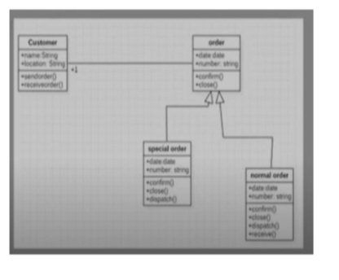
Algorithm:
1.Start
2.Define the Customer class with name and location.
3.Define the senderOrder() and receiverOrder() methods in the Customer class.
4.Define the Order class with date and number.
5.Define the confirm() and close() methods in the Order class.
6.Create the SpecialOrder class by inheriting the Order class.
7.Define the dispatch() method for SpecialOrder.
8.Create the NormalOrder class by inheriting the Order class.
9.Define the dispatch() and receive() methods for NormalOrder.
10.In the main() method, create a Customer object with name and location.
11.Create a SpecialOrder object with date and order number.
12.Create a NormalOrder object with date and order number.
13.Display the customer details.
-For the special order:
Confirm the order.
Dispatch the order.
close the order.
-For the normal order:
Confirm the order.
Dispatch the order.
Receive the order.
Close the order.
14.Call senderOrder() and receiverOrder() for the customer.
15.Stop.
UML Diagram:
┌──────────────────────────────────┐
│ Customer │
├──────────────────────────────────┤
│ - name : String │
│ - location : String │
├──────────────────────────────────┤
│ + Customer(name, location) │
│ + senderOrder() : void │
│ + receiverOrder() : void │
└──────────────────────────────────┘

┌─────────────────────────────┐
│ Order │
├─────────────────────────────┤
│ - date : String │
│ - number : String │
├─────────────────────────────┤
│ + Order(date, number) │
│ + confirm() : void │
│ + close() : void │
└──────────────┬──────────────┘
│
┌──────────┴──────────┐
│ │
│ │
┌────────▼─────────┐ ┌───────▼──────────┐
│ SpecialOrder │ │ NormalOrder │
├──────────────────┤ ├──────────────────┤
│ │ │ │
├──────────────────┤ ├──────────────────┤
│ + SpecialOrder() │ │ + NormalOrder() │
│ + dispatch() │ │ + dispatch() │
│ │ │ + receive() │
└──────────────────┘ └──────────────────┘

Source code:
class Customer {
String name;
String location;
Customer(String name, String location) {
this.name = name;
this.location = location;
}
void senderOrder() {
System.out.println(name + " is sending an order.");
}
void receiverOrder() {
System.out.println(name + " is receiving an order.");
}
}
class Order {
String date;
String number;
Order(String date, String number) {
this.date = date;
this.number = number;
}
void confirm() {
System.out.println("Order " + number + " is confirmed.");
}
void close() {
System.out.println("Order " + number + " is closed.");
}
}

class SpecialOrder extends Order {
SpecialOrder(String date, String number) {
super(date, number);
}
void dispatch() {
System.out.println("Special order " + number + " is dispatched.");
}
}
class NormalOrder extends Order {
NormalOrder(String date, String number) {
super(date, number);
}
void dispatch() {
System.out.println("Normal order " + number + " is dispatched.");
}
void receive() {
System.out.println("Normal order " + number + " is received.");
}
}
public class OrderDemo {
public static void main(String[] args) {
Customer customer = new Customer("Meghana", "Srikakulam");
SpecialOrder specialOrder = new SpecialOrder("11-08-2026", "S101");
NormalOrder normalOrder = new NormalOrder("11-08-2026", "N101");

System.out.println("Customer Details");
System.out.println("Name : " + customer.name);
System.out.println("Location : " + customer.location);

System.out.println("\nSpecial Order");
specialOrder.confirm();
specialOrder.dispatch();
specialOrder.close();

System.out.println("\nNormal Order");
normalOrder.confirm();
normalOrder.dispatch();
normalOrder.receive();
normalOrder.close();

System.out.println();
customer.senderOrder();
customer.receiverOrder();
}
}

Output:
